|  |
| --- |
| HUTECH UNIVERSITY OF TECHNOLOGY  *****************  **WEB PRAMMING**  **Final Test Report**    **Group:**   1. **Do Hoang Cong Danh_2011064187** 2. **Tran Nguyen Bao Toan_2011061154**   **Ho Chi Minh City, 12/2022** |

**SETUP**

Step 1:

Using Git to clone the project on GitHub with link:

<https://github.com/BToan22/CMP175_WebFinalProject.git>

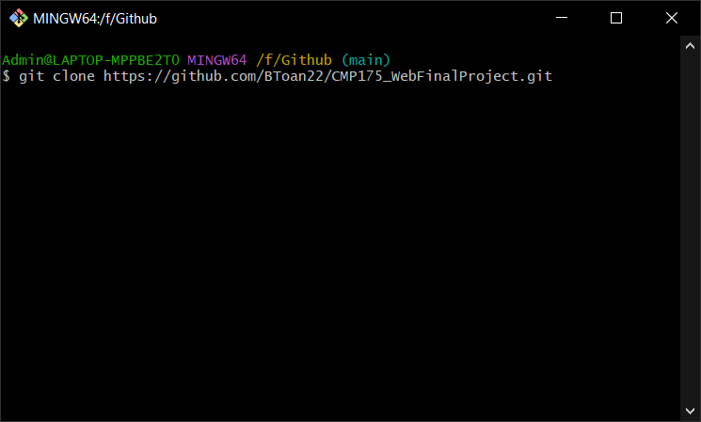

Step 2:

Using the WebFinalScript file and excute it on Microsoft SQLServer.

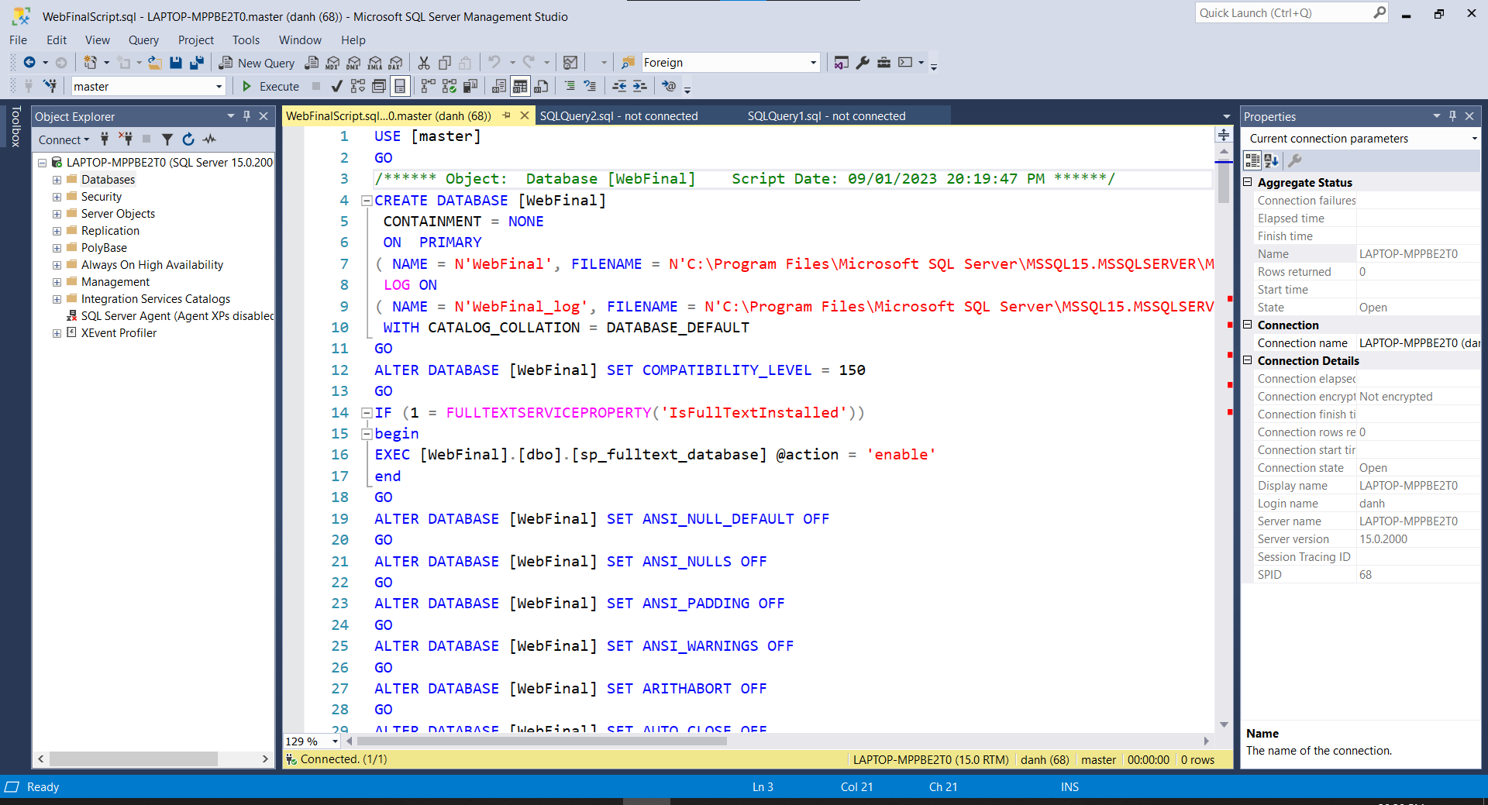

Step 3:

Delete table dbo.Provinces and right click on database WebFinal 🡪 Task 🡪 Import Data and import file Provinces.xls.

Step 4:

Open folder WebFinal and double click file WebFinal.sln to run project on Visual Studio.

Step 5:

Open LoginController in project.

In line 117 change the Server equal to your server name in Microsoft SQLServer.

Change user id and password equal the user login you have.

Step 6:

Excute the WebFinal project

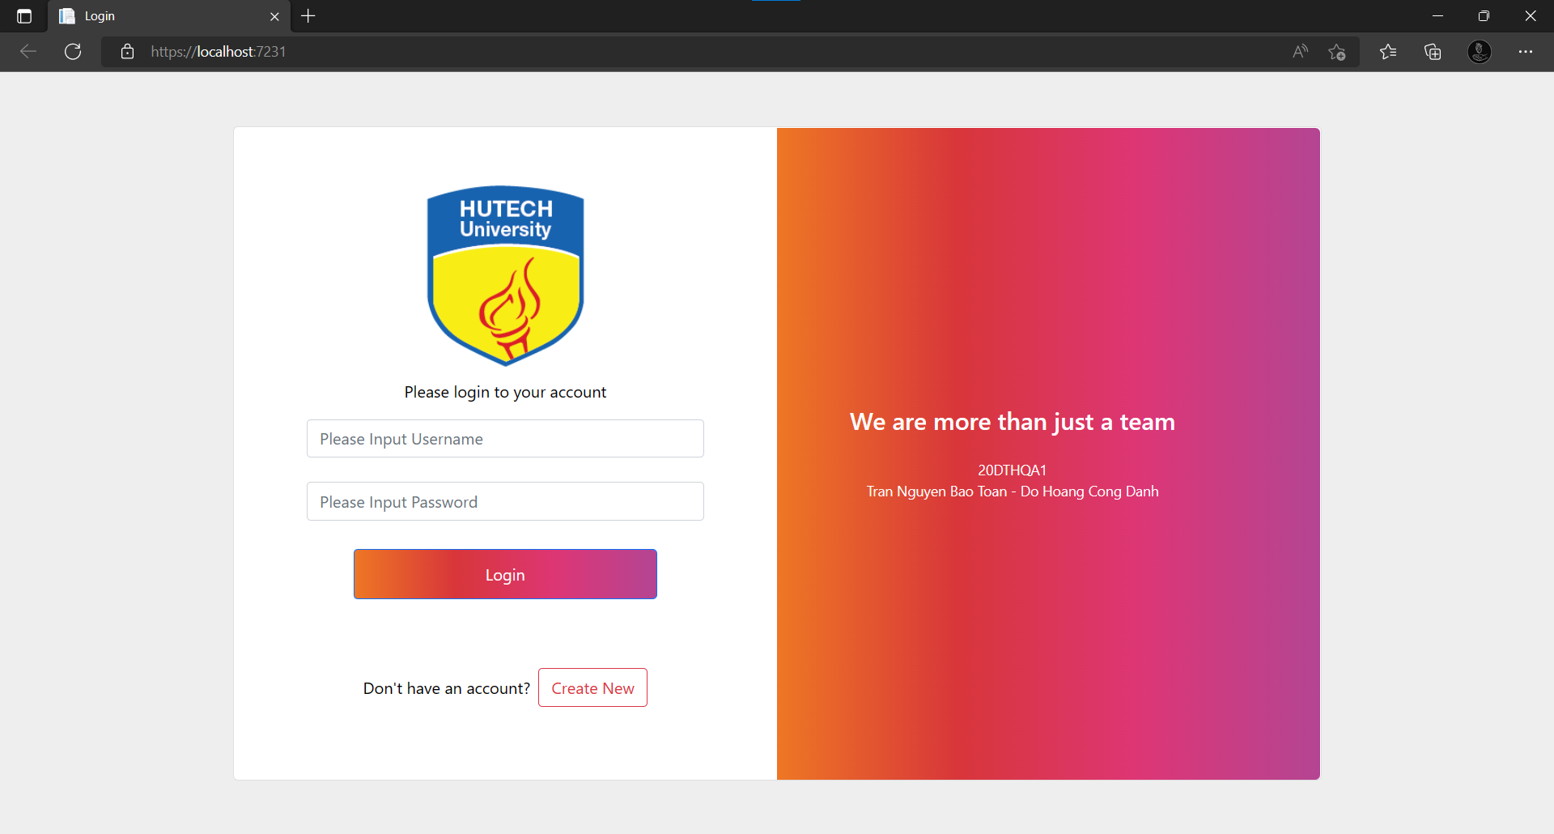

Step 7:

Click Create New to Register and click Register

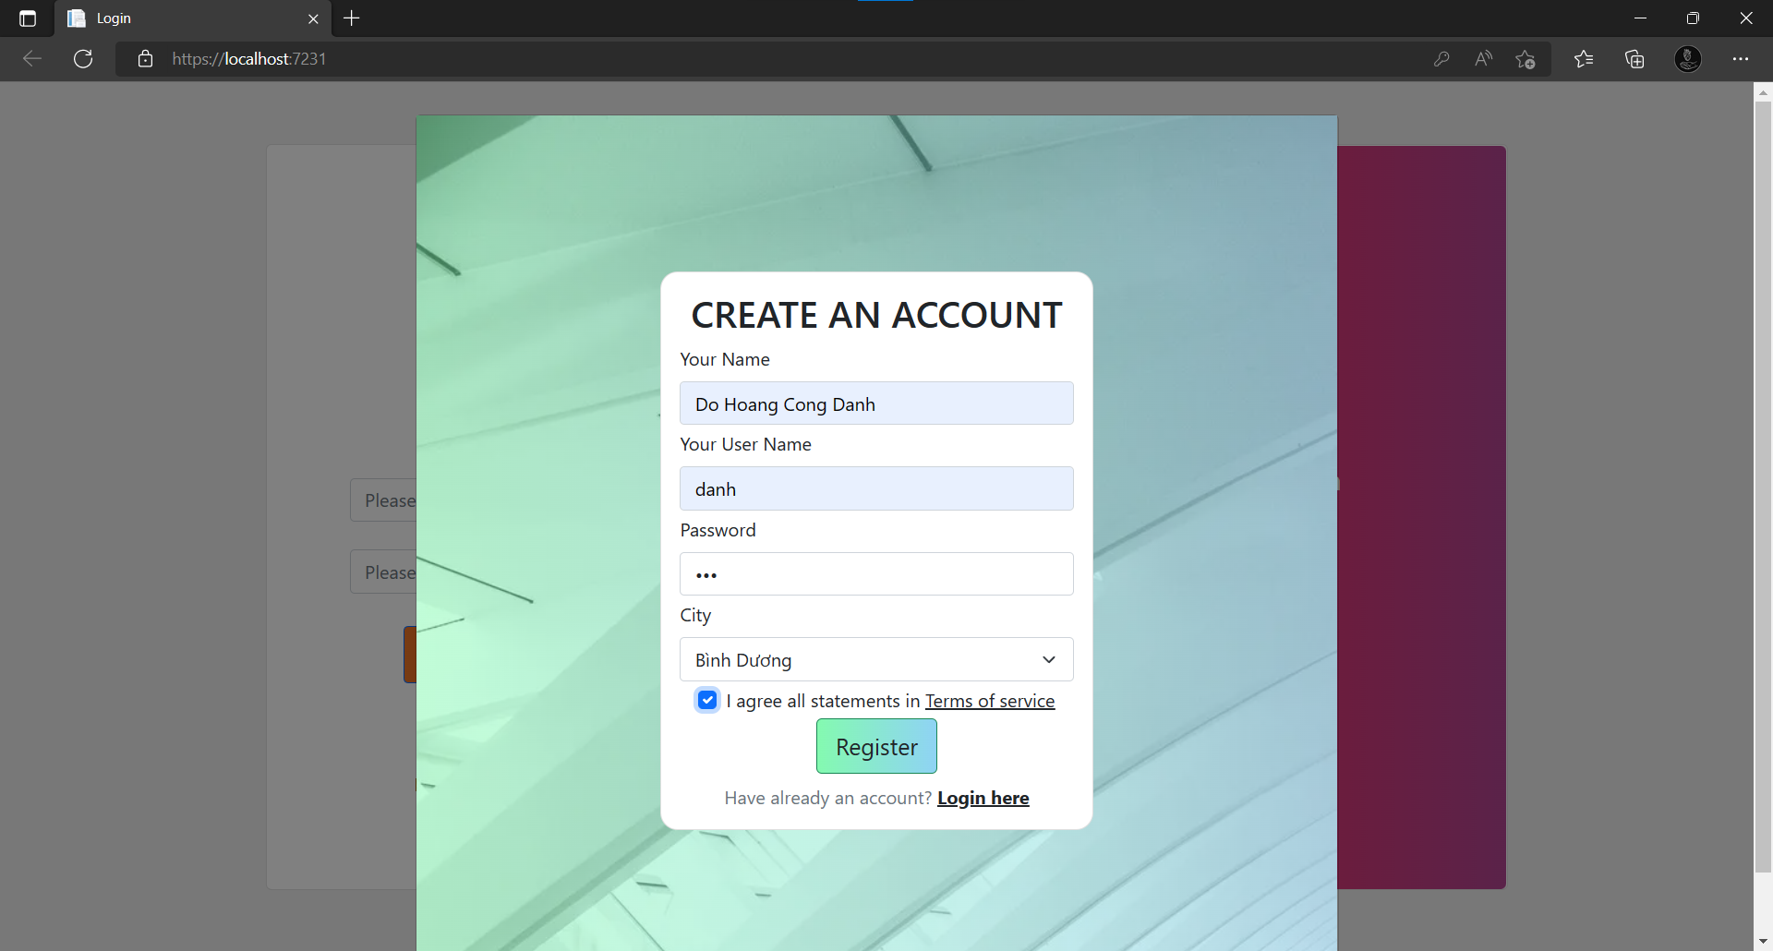

Step 8: Click Home Page to return the login form and fill your user name and password

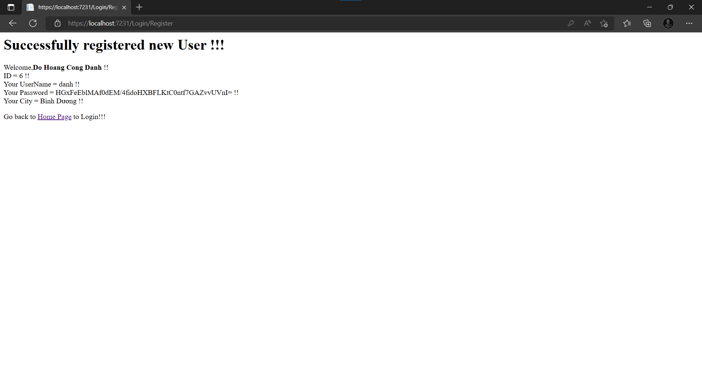

LIKE THIS and click login

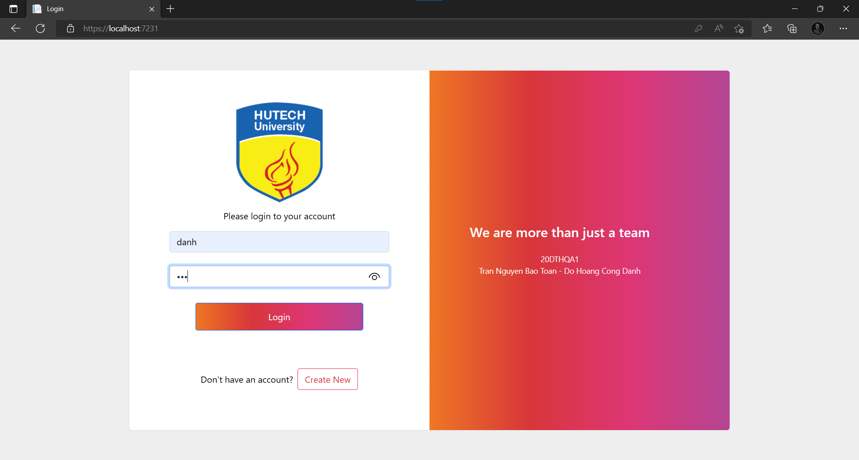

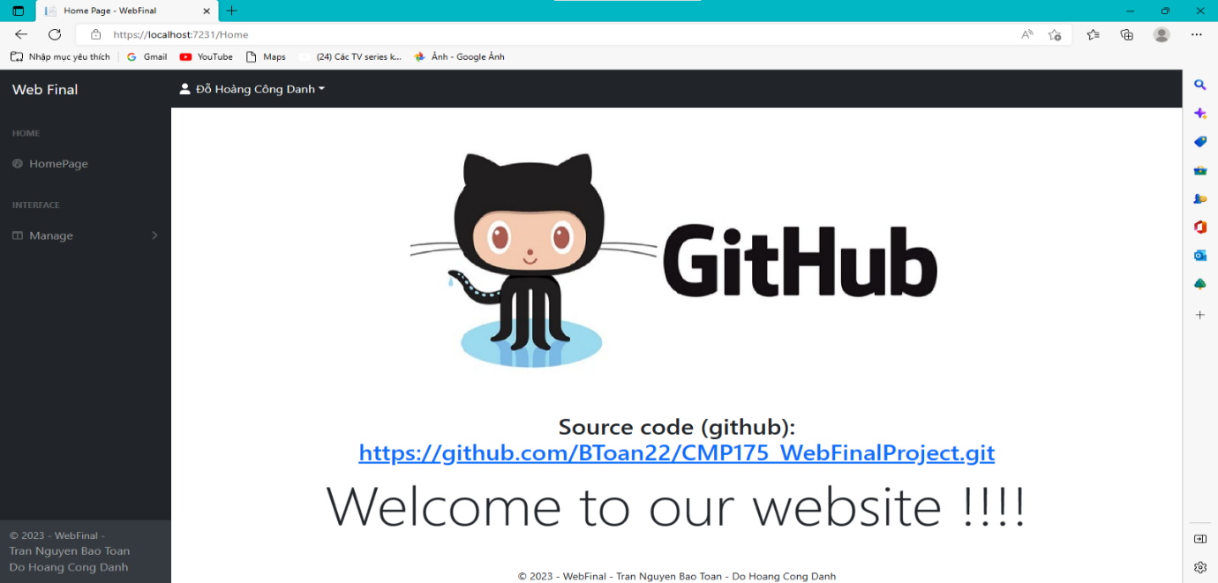

**FEATURE:**

* Click on fullname to open two feature: Change pass and log out

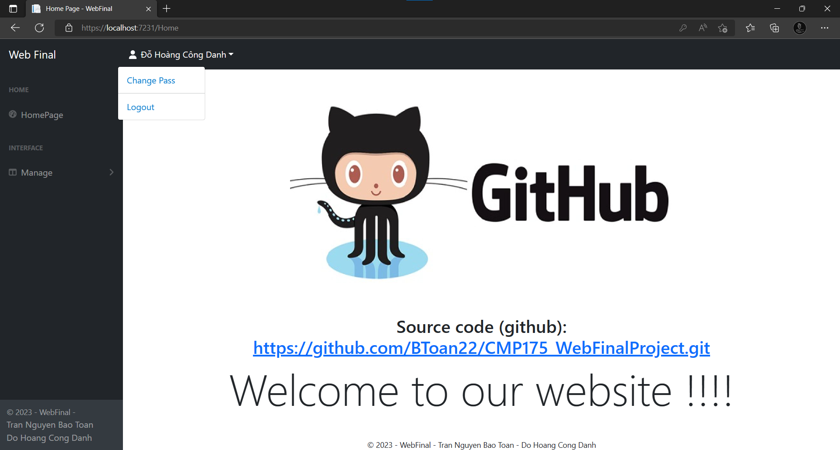

* Change Pass form

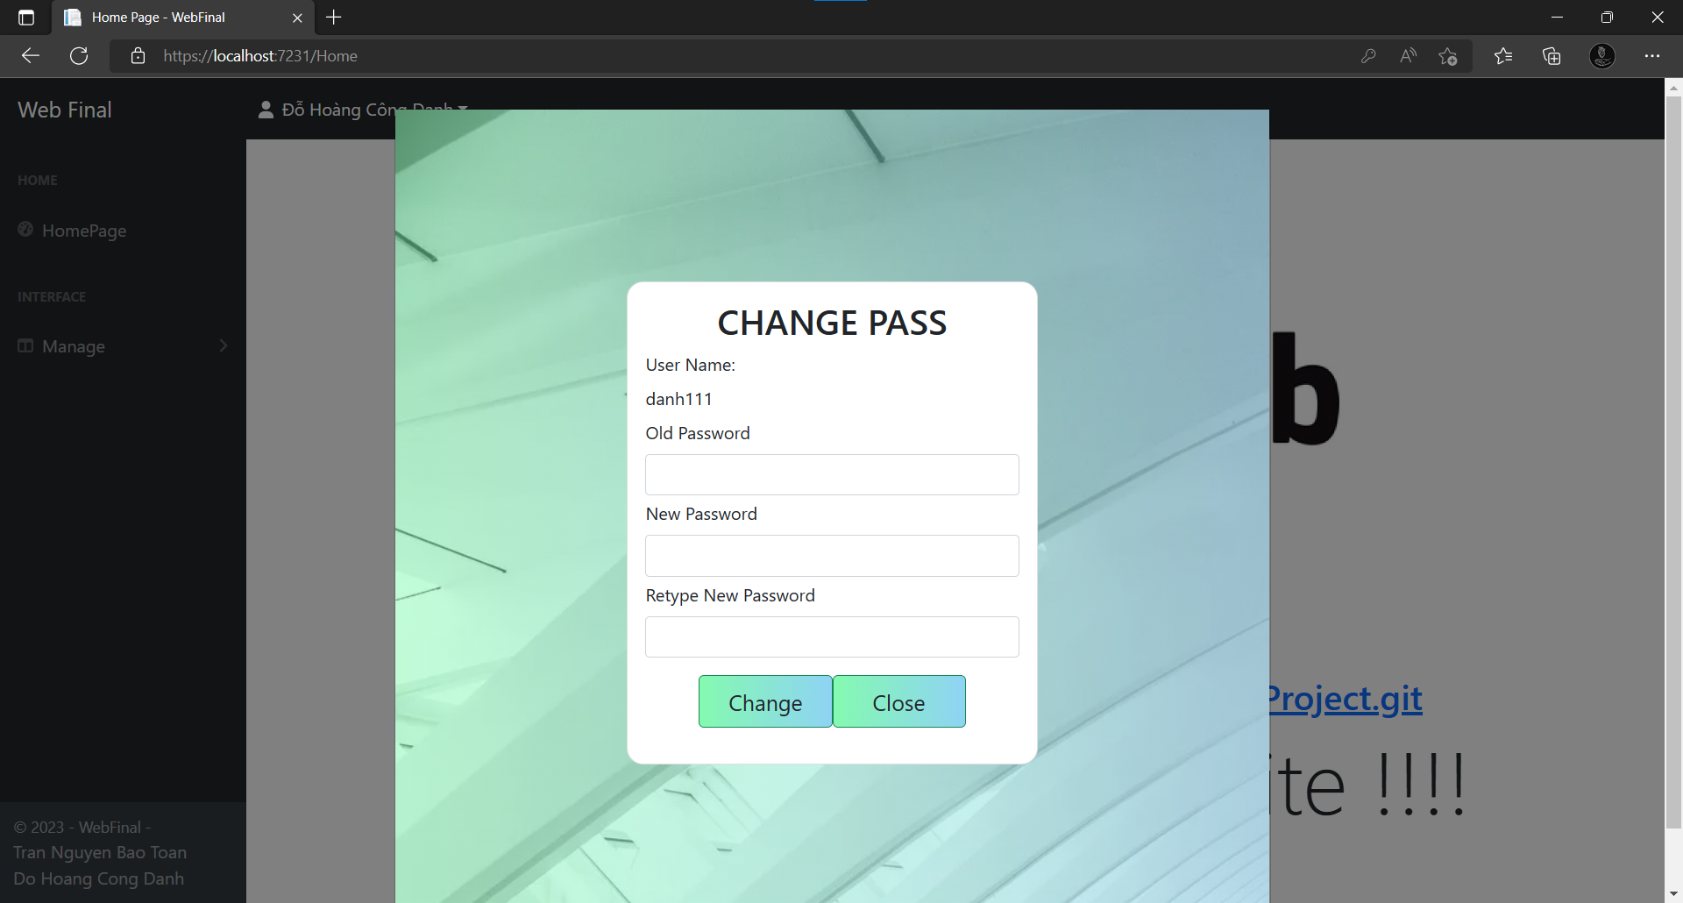

* Click Manage 🡪 Student/Lecturer/Subject to open Student/Lecturer/Subject Manage form
* STUDENT FORM

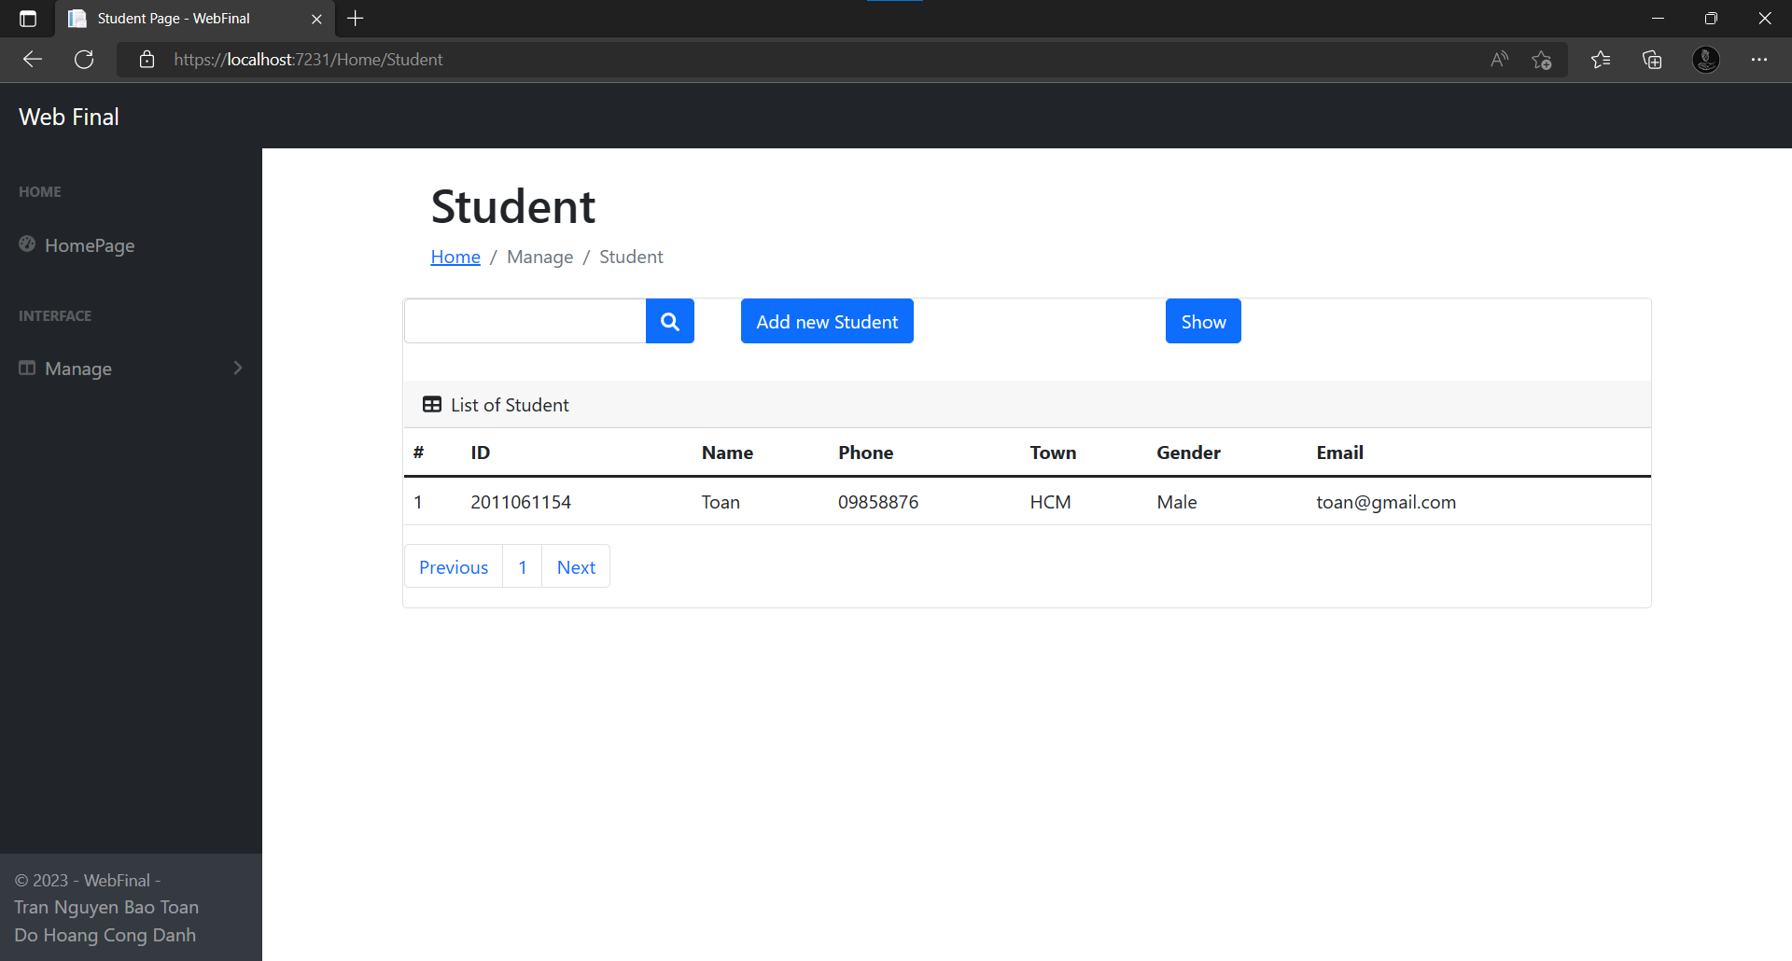

* Click show to show all data in database

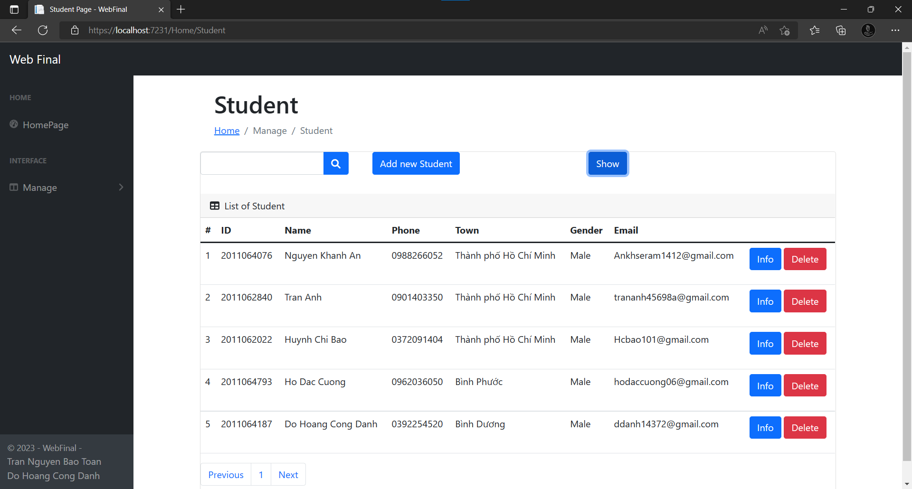

-Click Add new Student to Add new object

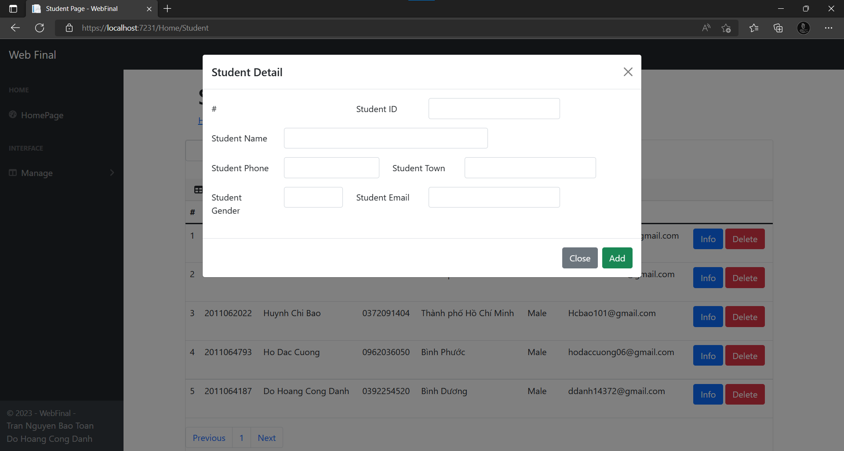

-Click info to open Details of this student

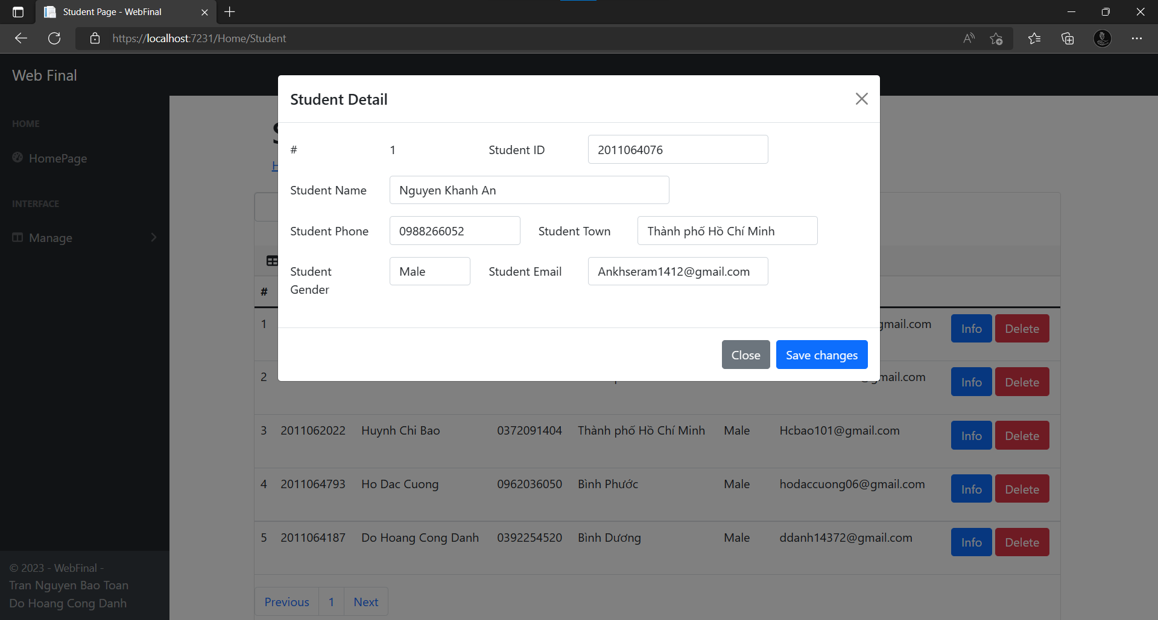

* You can change info and click save change to apply change

-Click Delete to delete the object you want

-You can search by student id

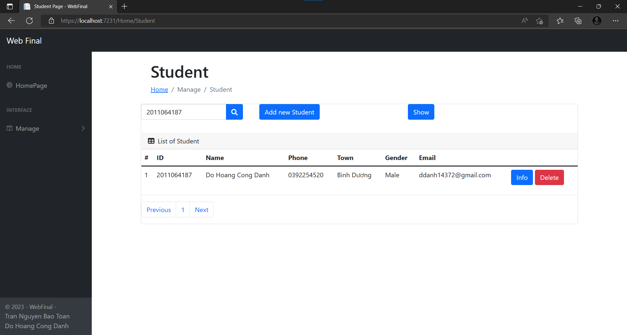

**LECTURER FORM**

-Click show to show all data from database

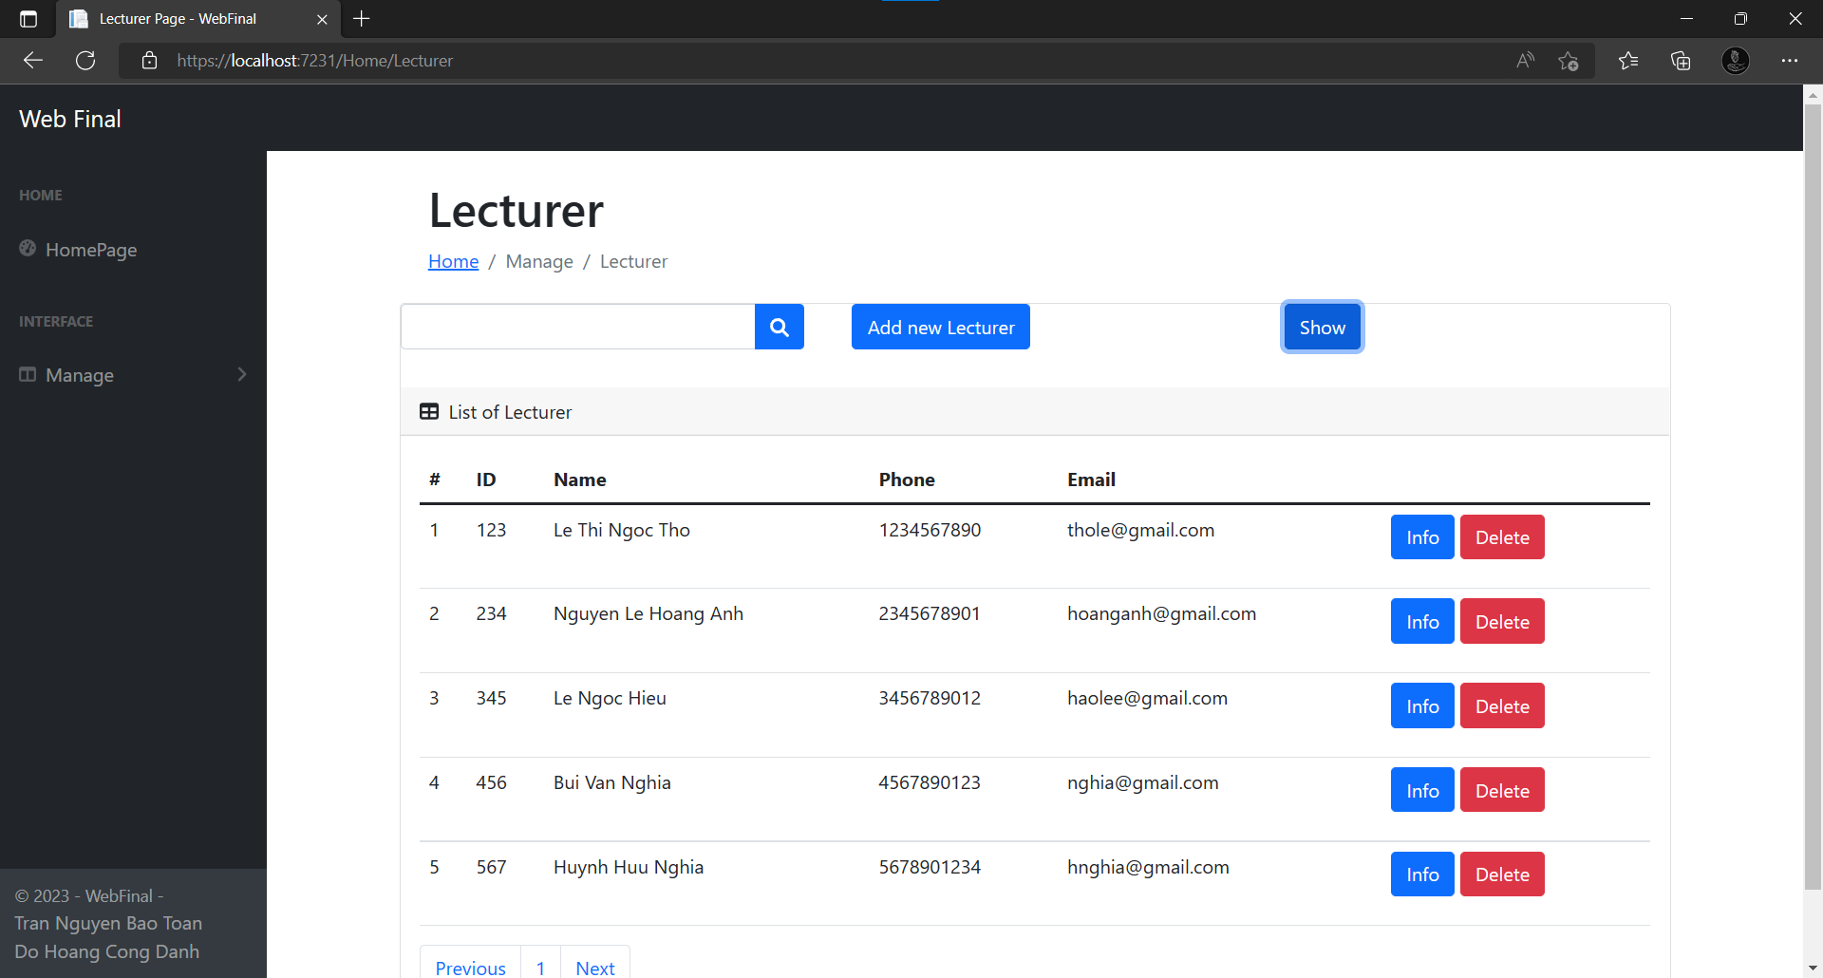

-Click add new Lecturer to add new Lecturer object

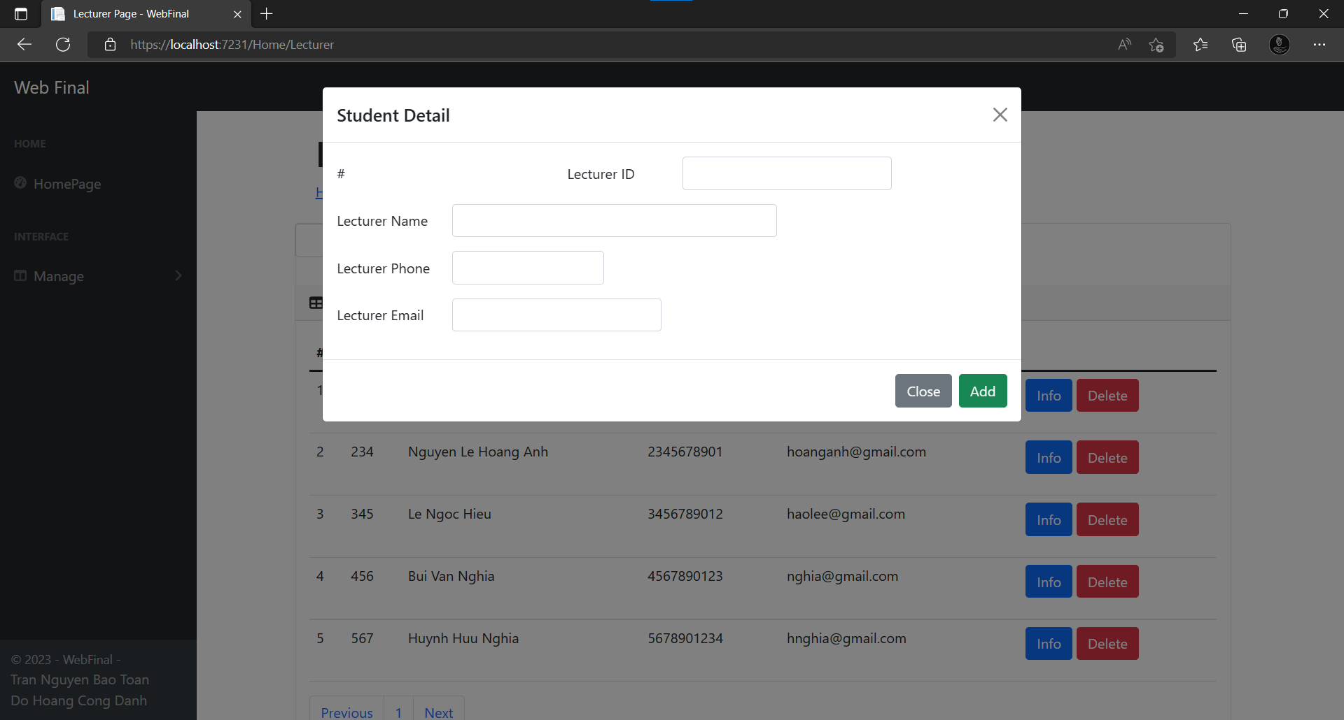

-Click info to show the details of Lecturer and change the information. Click Save Change to apply

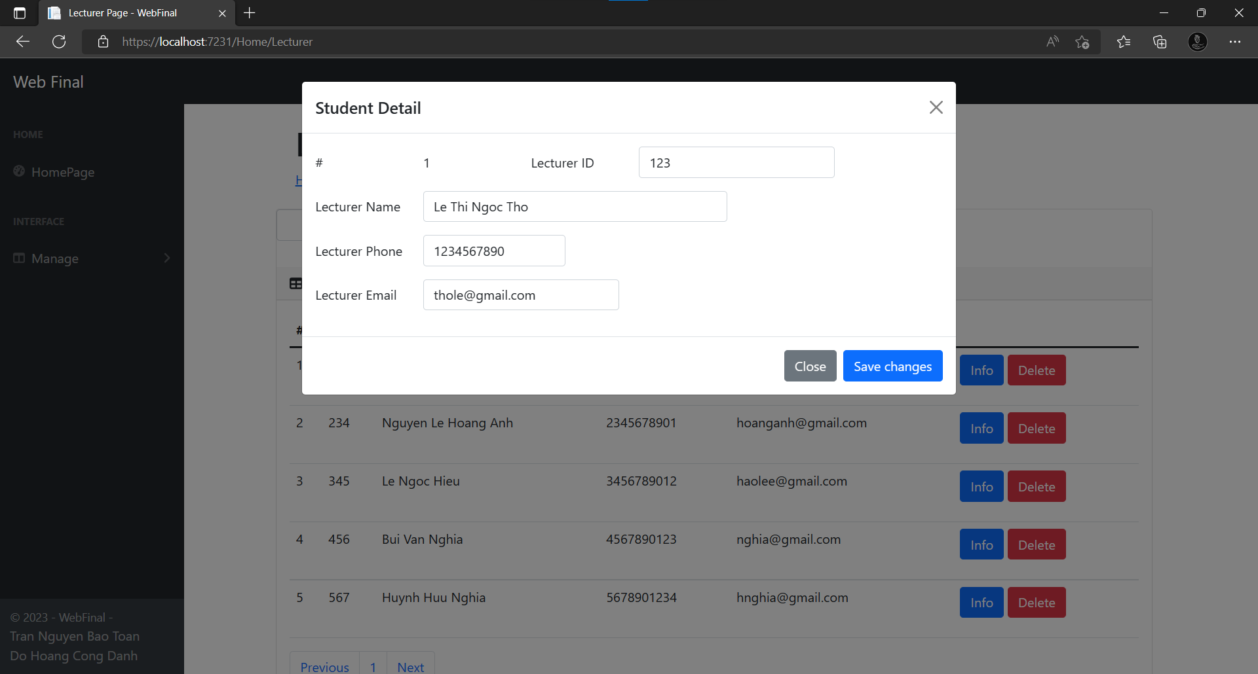

-Click Delete button to delete the Lecturer

-You can search the Lecturer by Lecturer ID

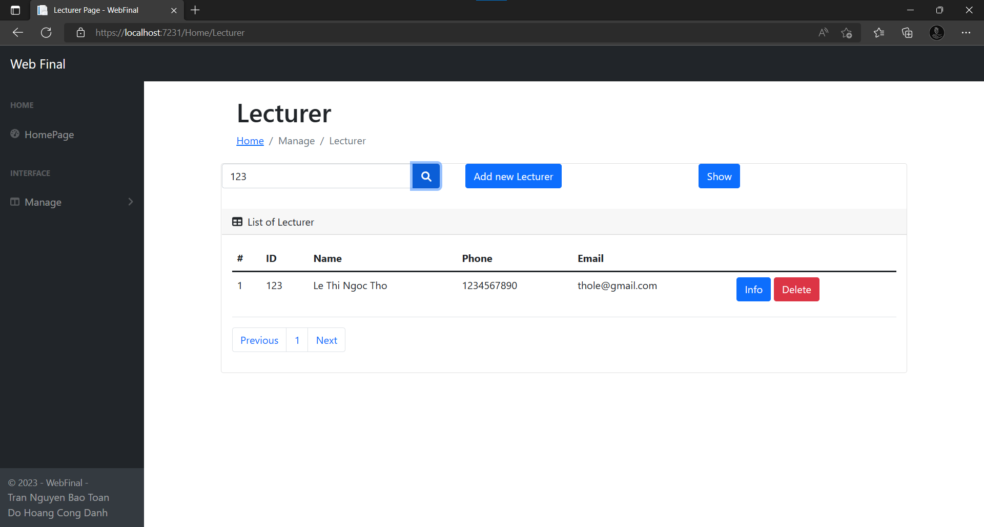

* **SUBJECT FORM**
* Select Major

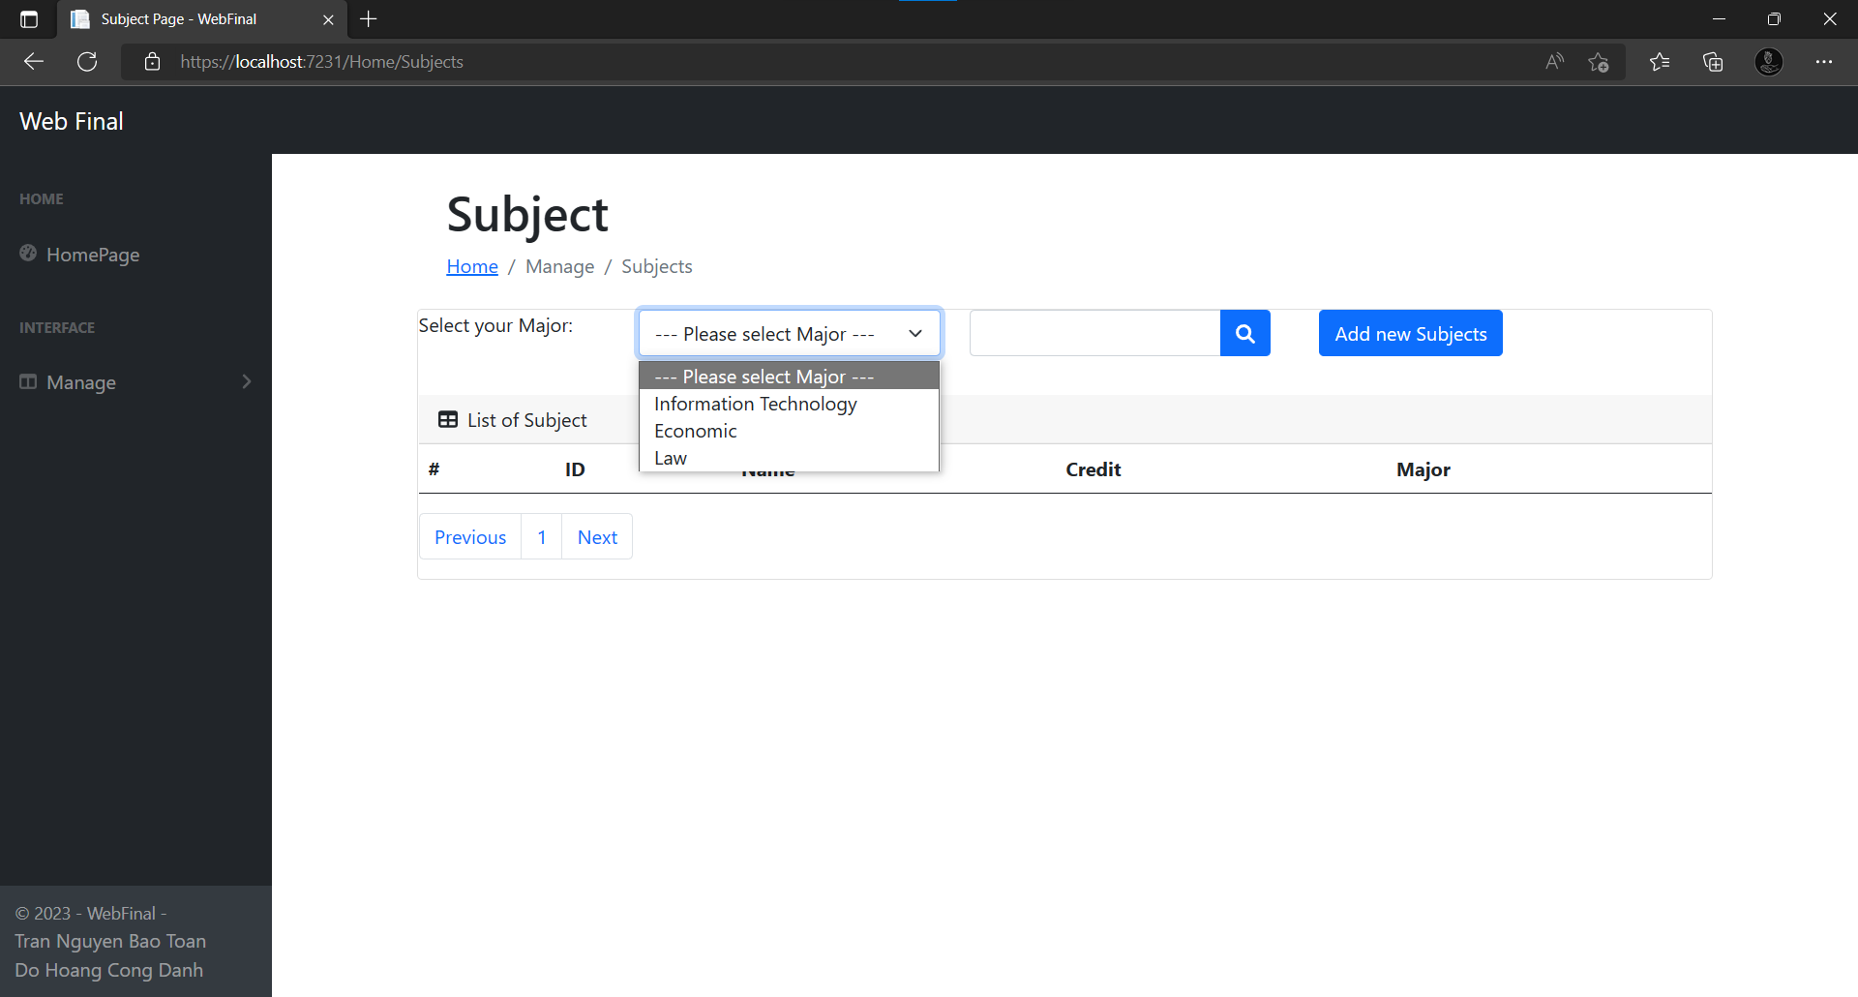

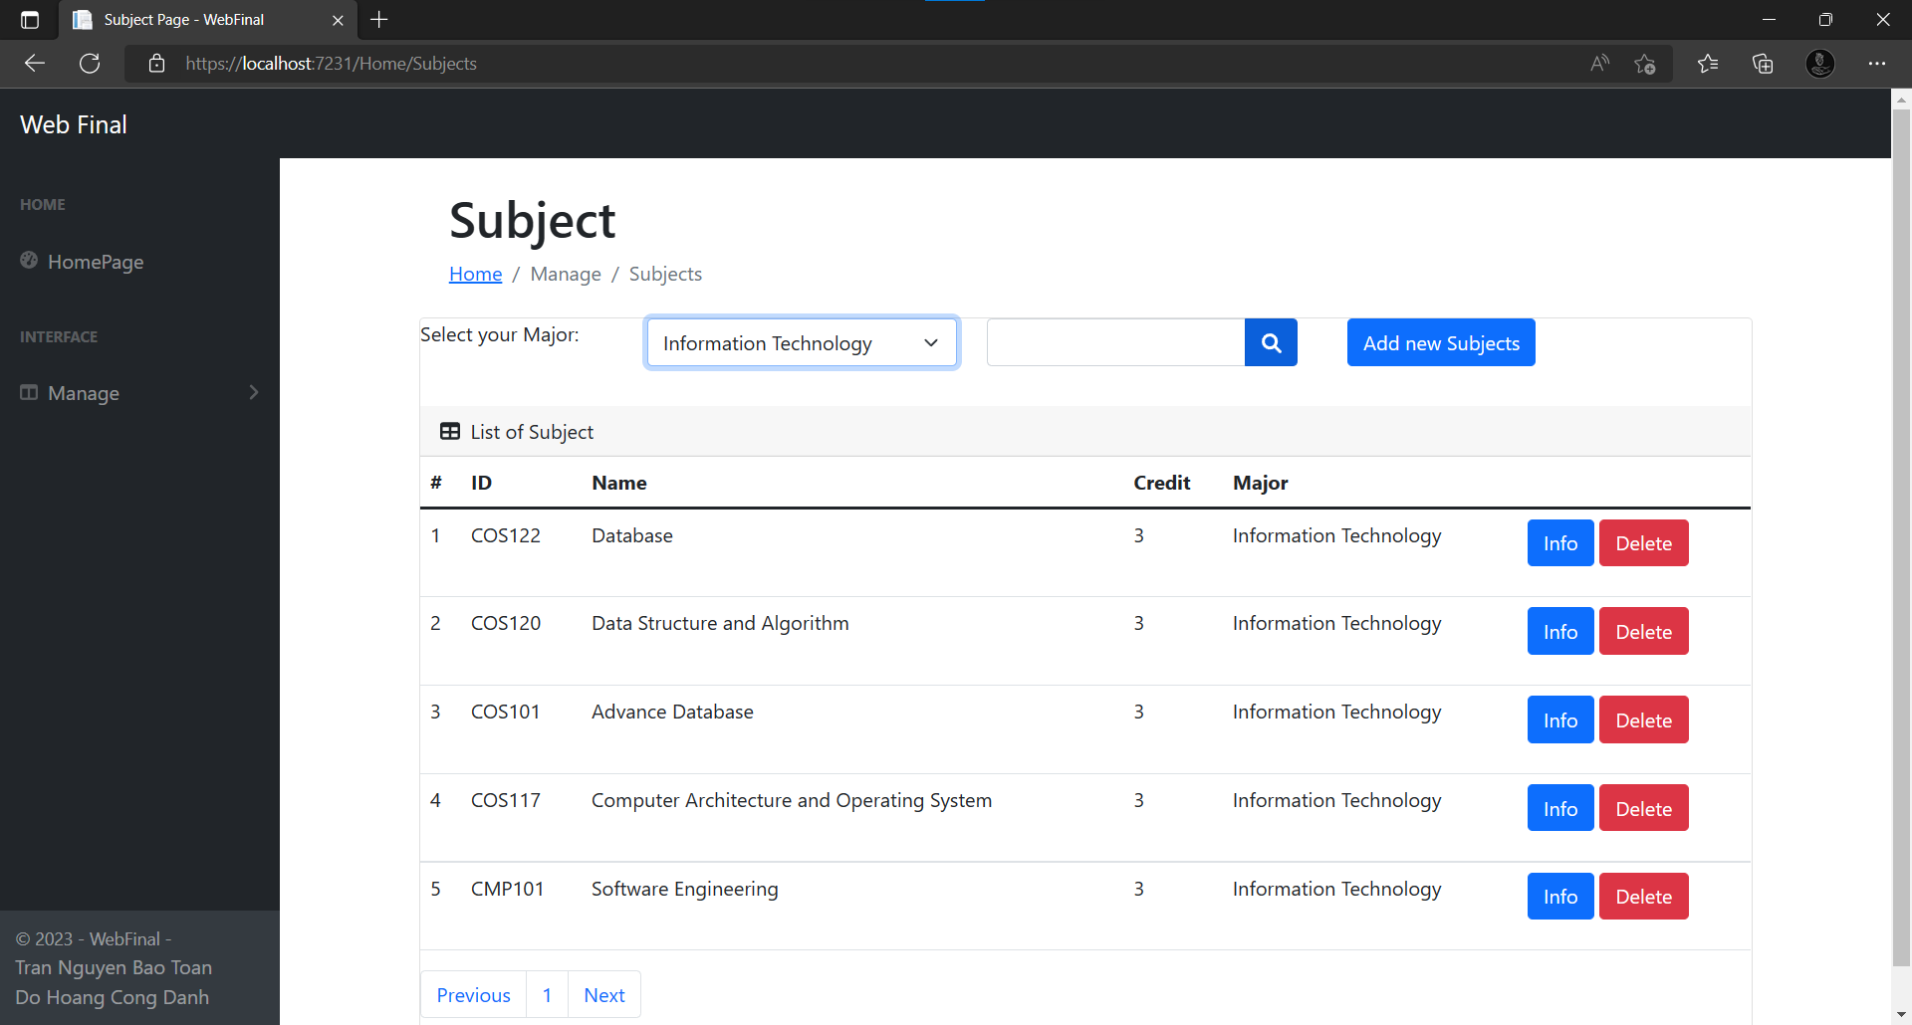

-Click Add new Subject to add

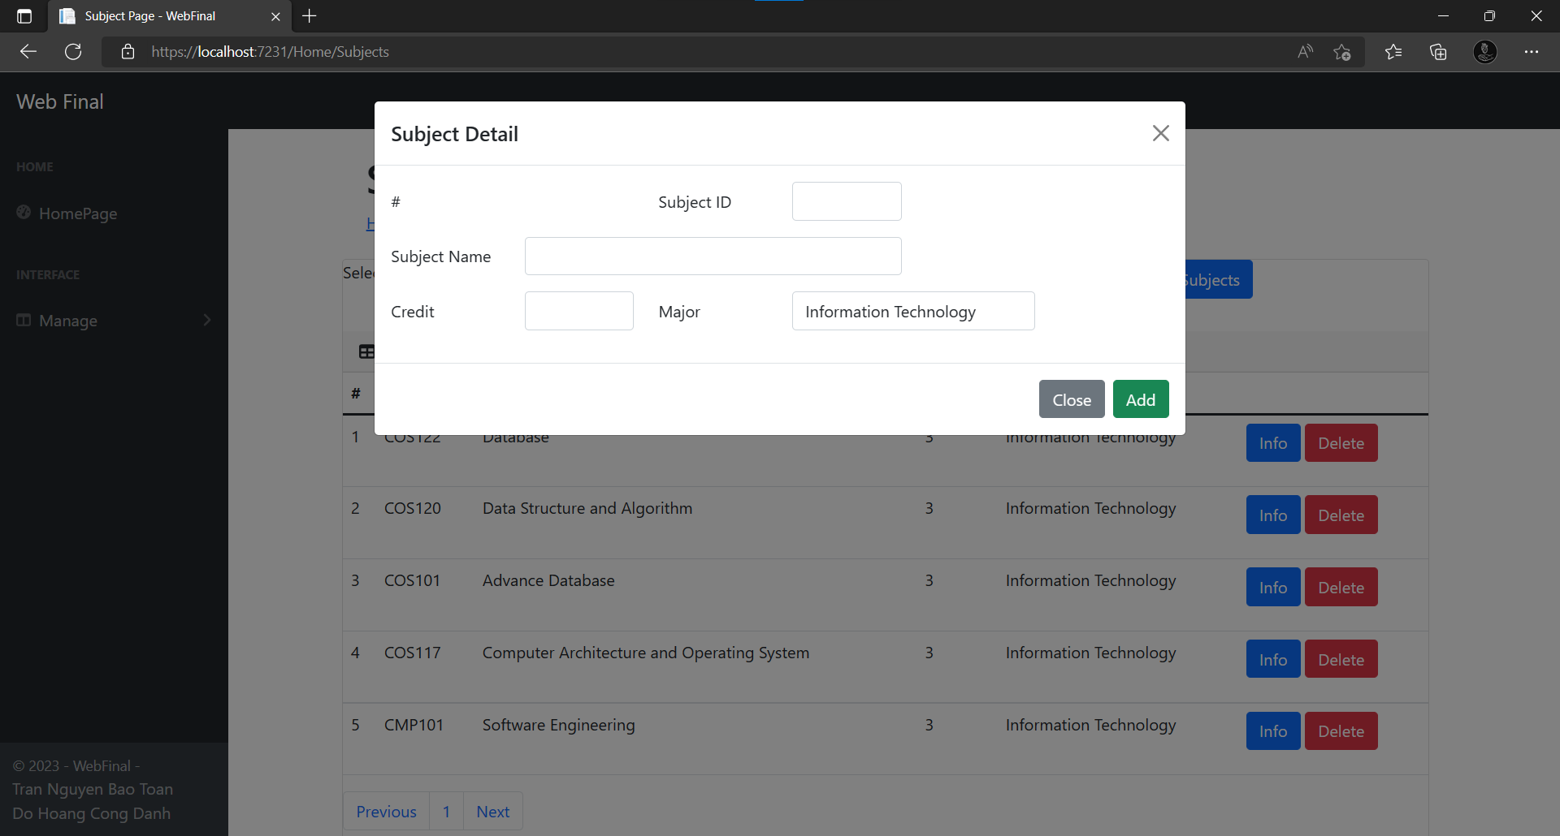

-Click info to see Subject Details

-You can change the info of subject and click Save Changes to apply

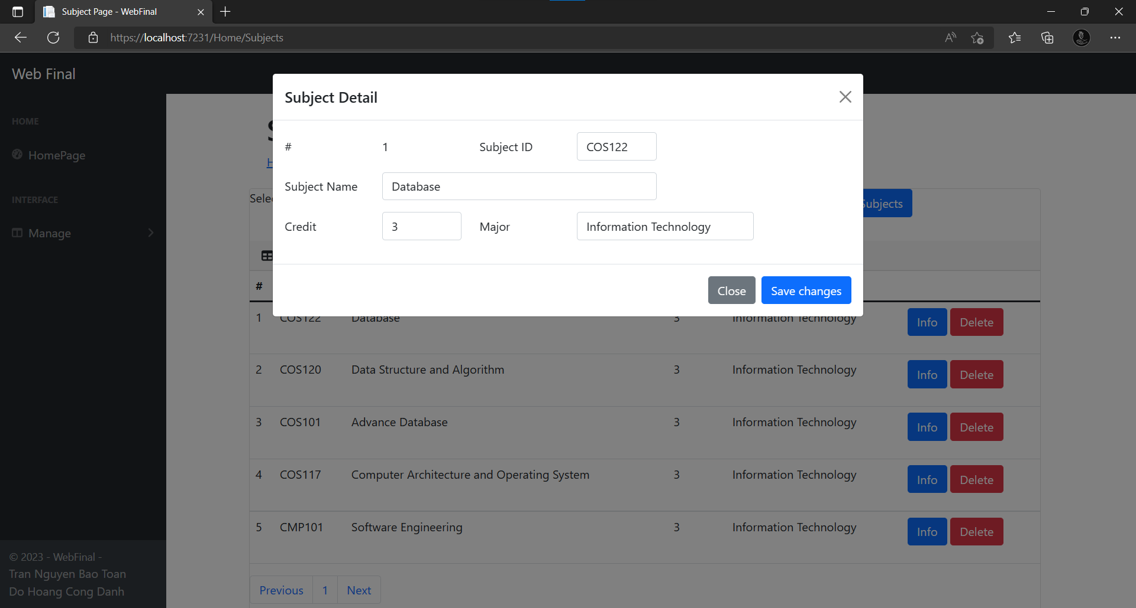

* You can delete Subject by Delete button
* You can search Subject by Subject ID

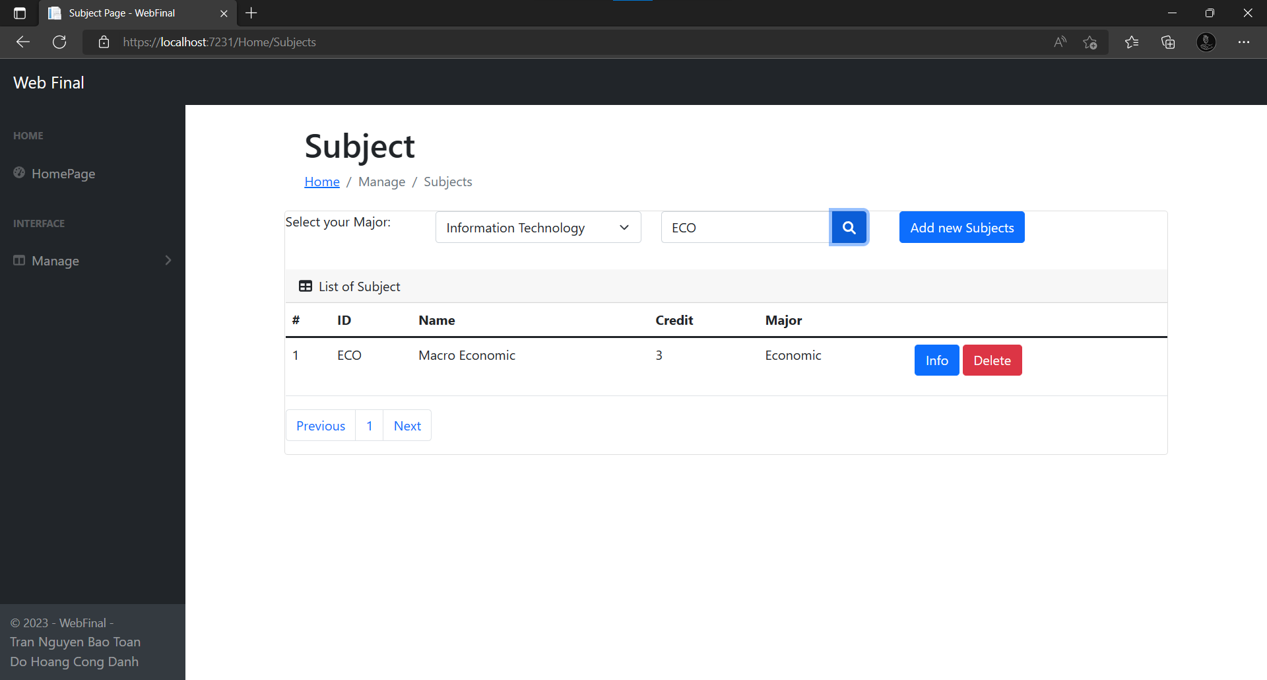

Relate source:

<https://startbootstrap.com/admin-dashboard?showAngular=false&showVue=false&showPro=false>

<https://mdbootstrap.com/docs/standard/extended/registration/?fbclid=IwAR3NsN1oSTPddQTTfmJucbjLRb1ZMjPqb7Sfgxj_ar86IJZSJlkqoYpHbJk#section-7>

GitHub link:

<https://github.com/BToan22/CMP175_WebFinalProject.git>